Get Distance Between 2 cities by using Google API Key

Use the Google Clou Platform with Google Account

Create a Project

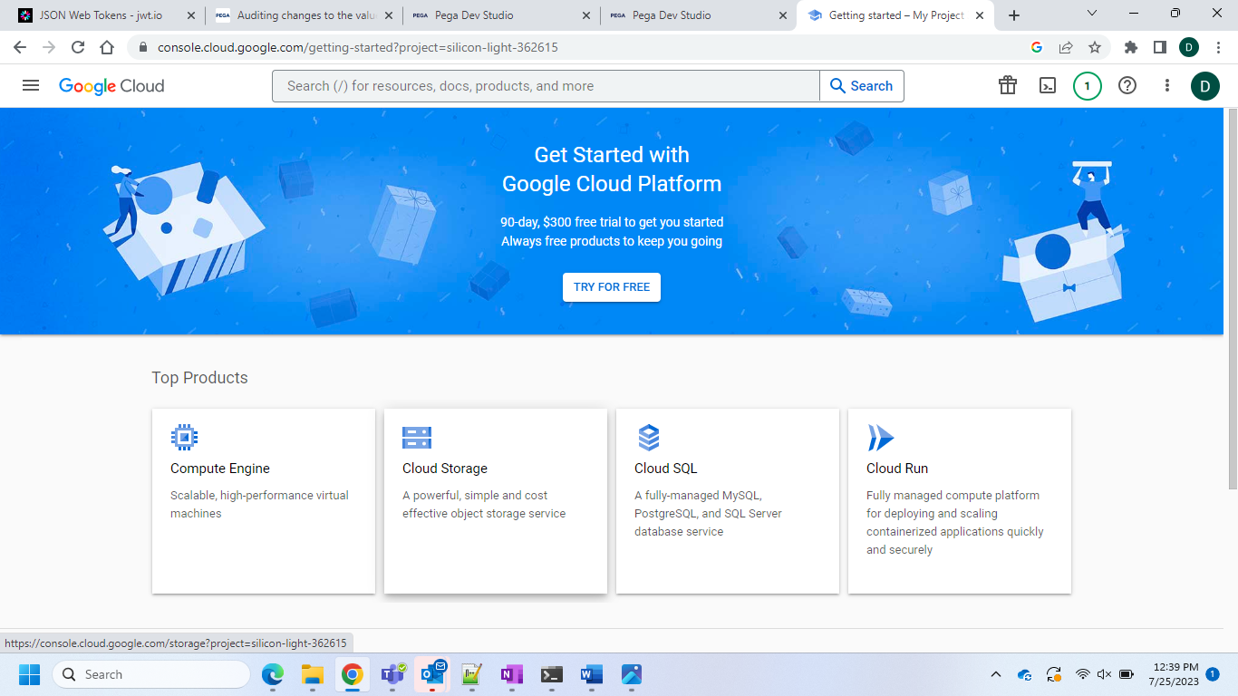

And then go to your projects

After successful creation of the project… click on the enabled API and then select Distance Matrix API and enable it

After the successful creation of the API you can restrict the key for the Distance Matrix API

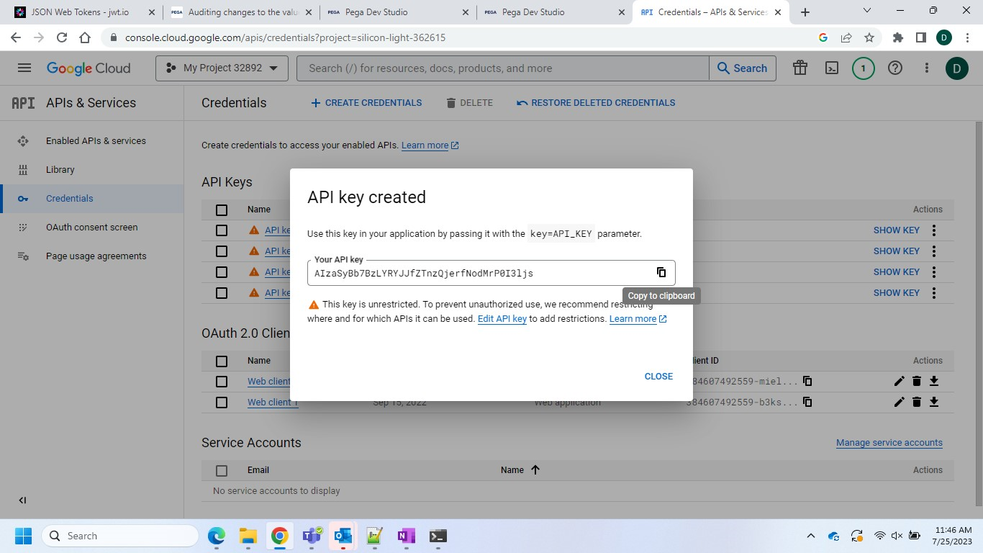

And then you have to go for the API key and go for the restrict API in the Credentials section by editing it

And then try to restrict the key

And then now come to Pega Side Configuration..

Create REST Integration..

Give the details like this..

Since I had the No billing Account it is showing this..

After I created the billing account it will show response so for creating billing account it will show the Billing Account ID like this

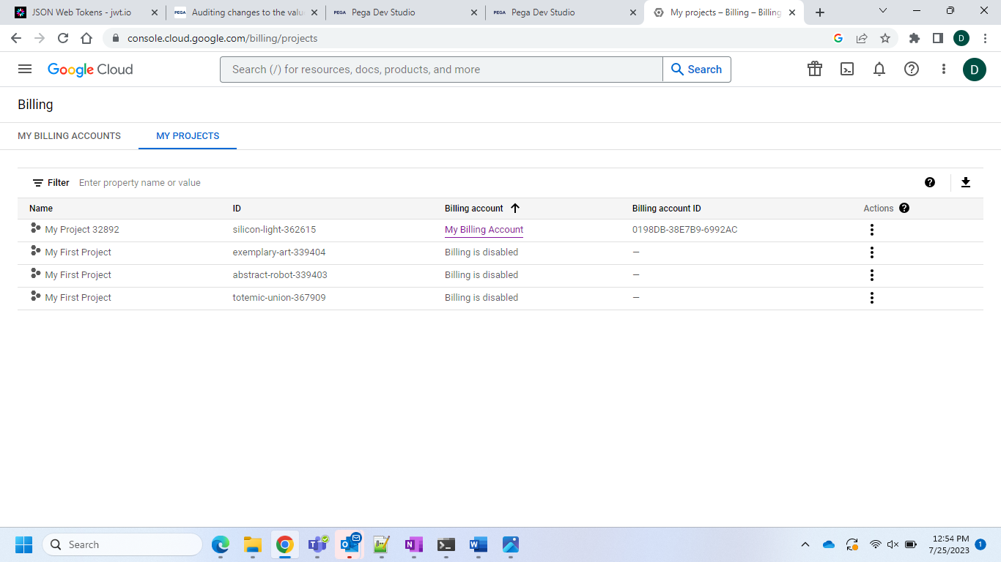

And after that you have to do the same in the integration step

And after that go for that click next and do the create..

Then again create the section in the data class of this like this respectively..

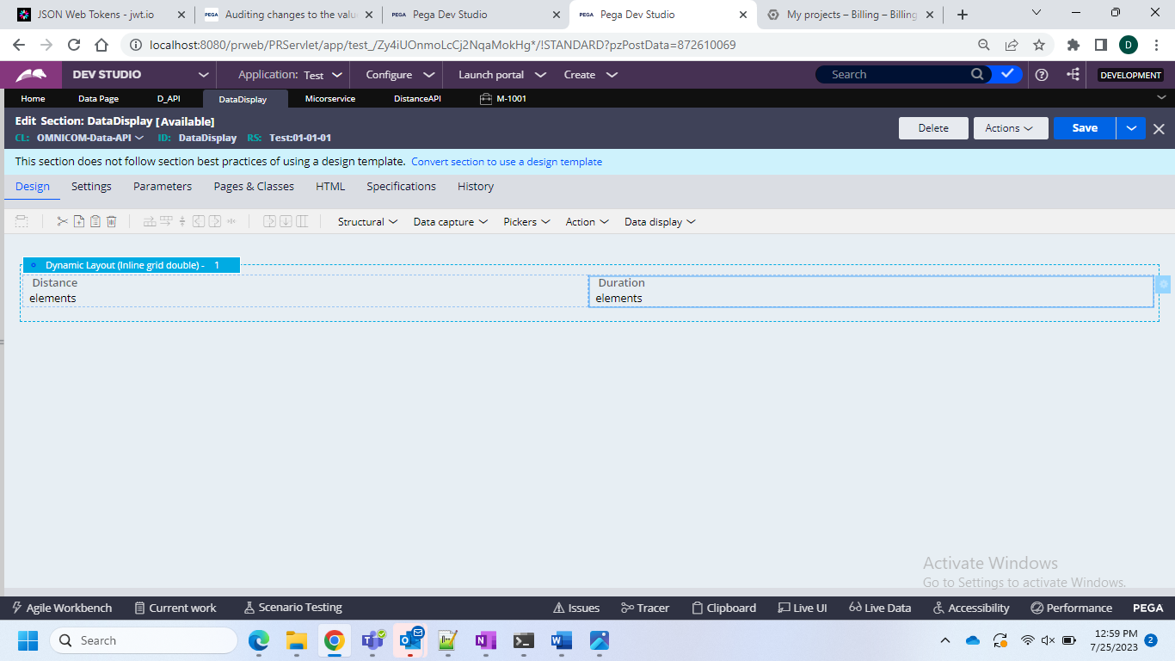

And then go for the case type creation and then go for the stage with one flow creation

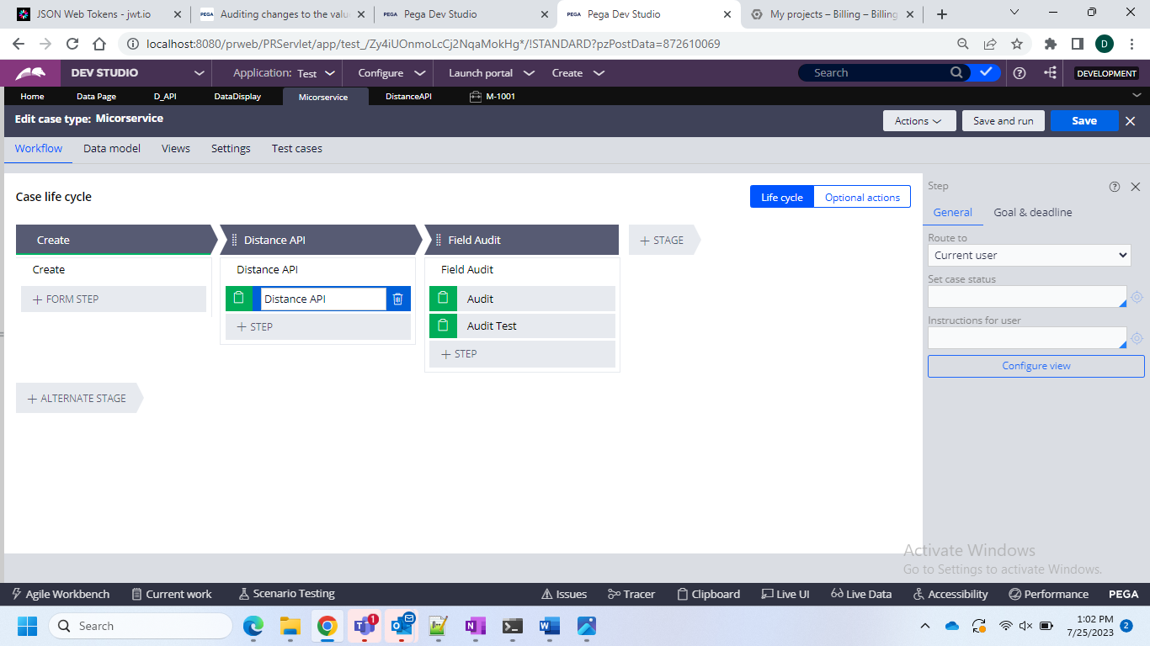

And in this in the first create 2 fields in the first stage

And in this please give the 2 properties which you should create in the data class

And in that get the button and on that give the refresh section

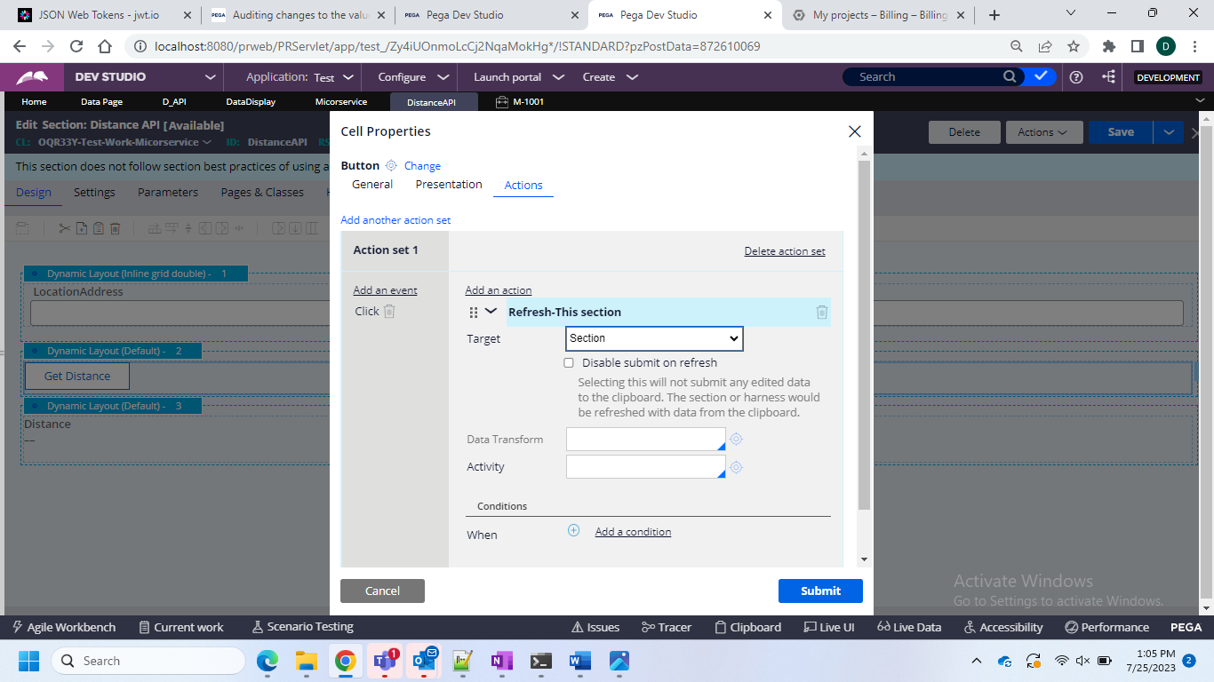

And after that please embed the section and then go for the import the previously created section

And then save and run the case type

On the screen you will see the results..

